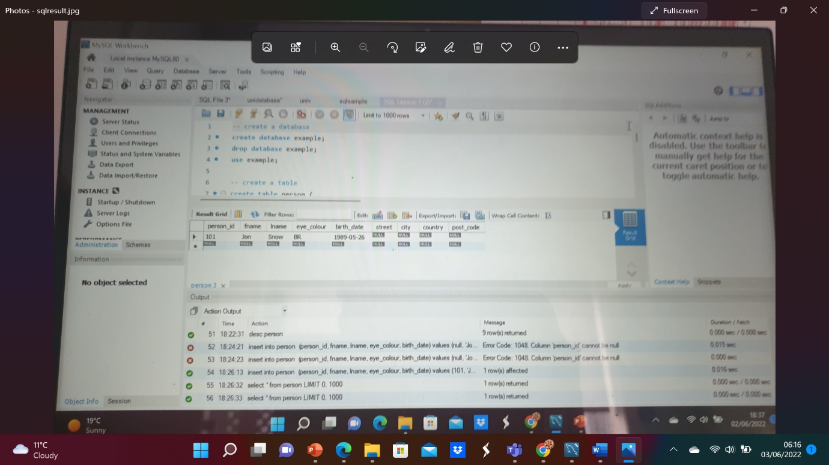
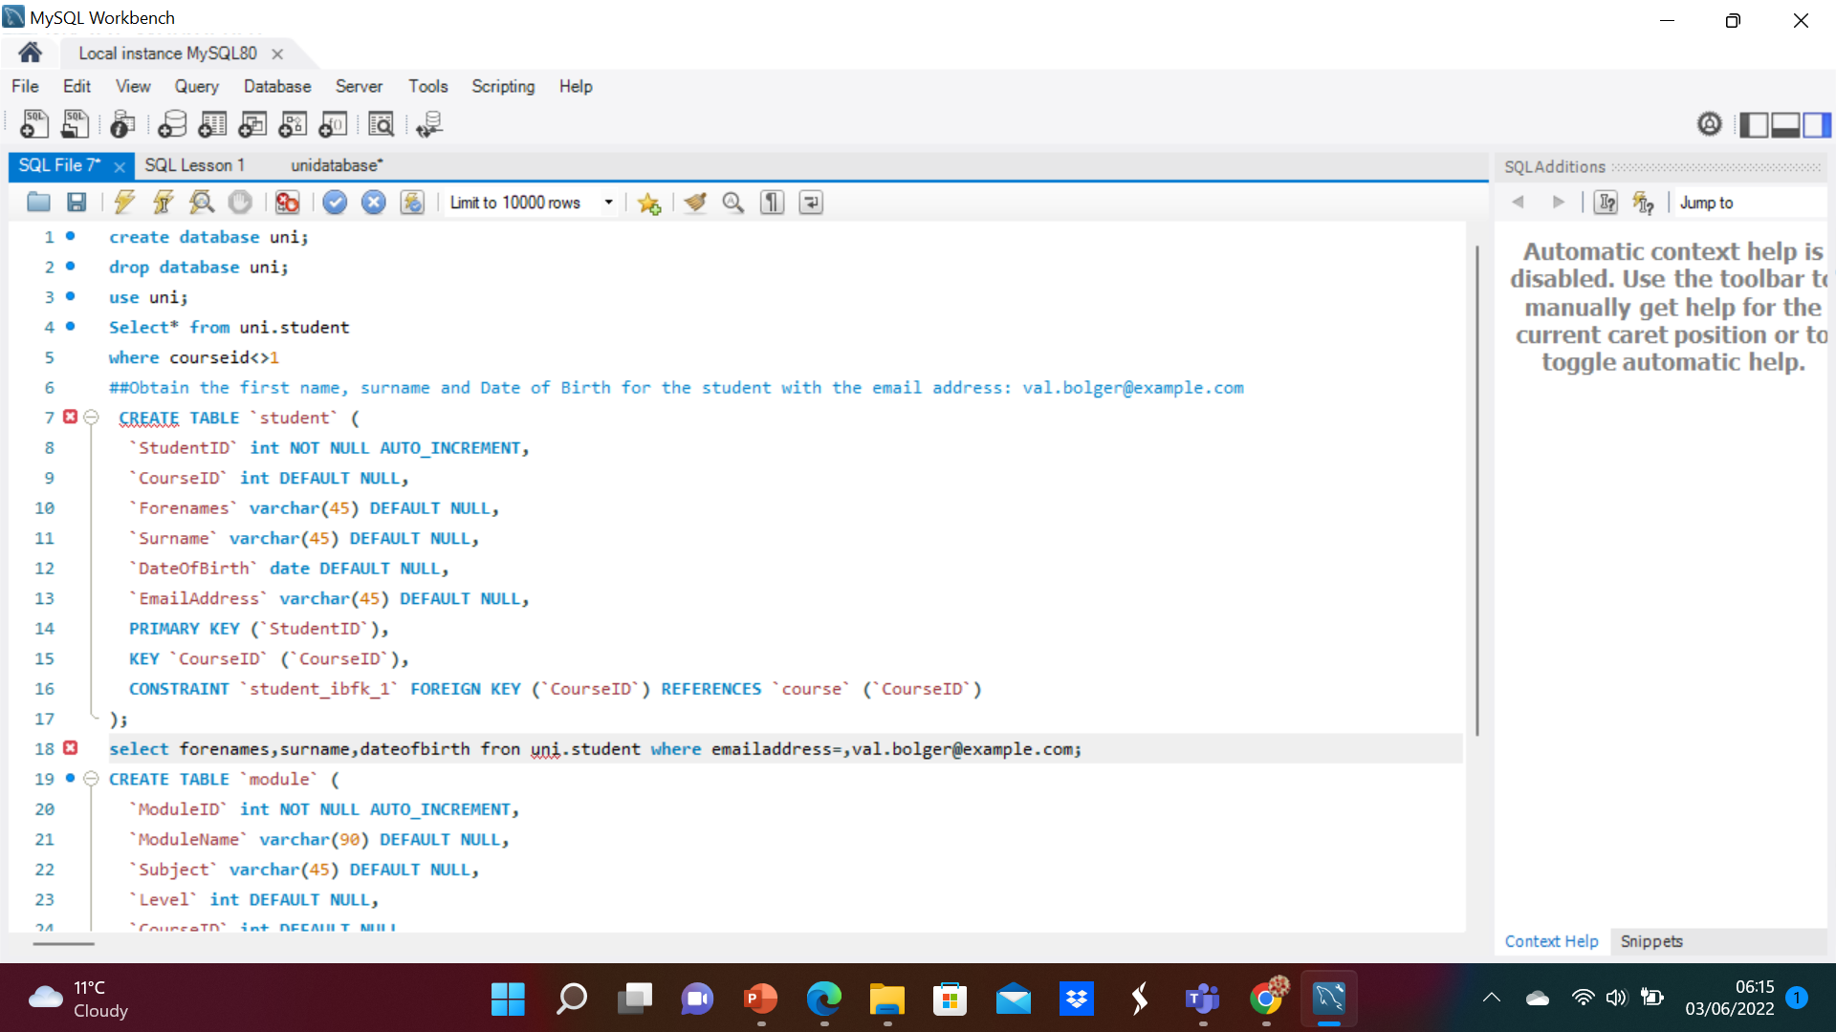

- Using our Uni Database
- Obtain all information on the Students not attending course 1
create database uni;
drop database uni;
use uni;
Select* from uni.student where courseid<>1
- Obtain the first name, surname and Date of Birth for the student with the email address: val.bolger@example.com

select forenames,surname,dateofbirth fron uni.student where emailaddress=,val.bolger@example.com;

- Obtain a list of the modules which have the subject Economics
Select * from uni.module where subject =’Ecnomics’
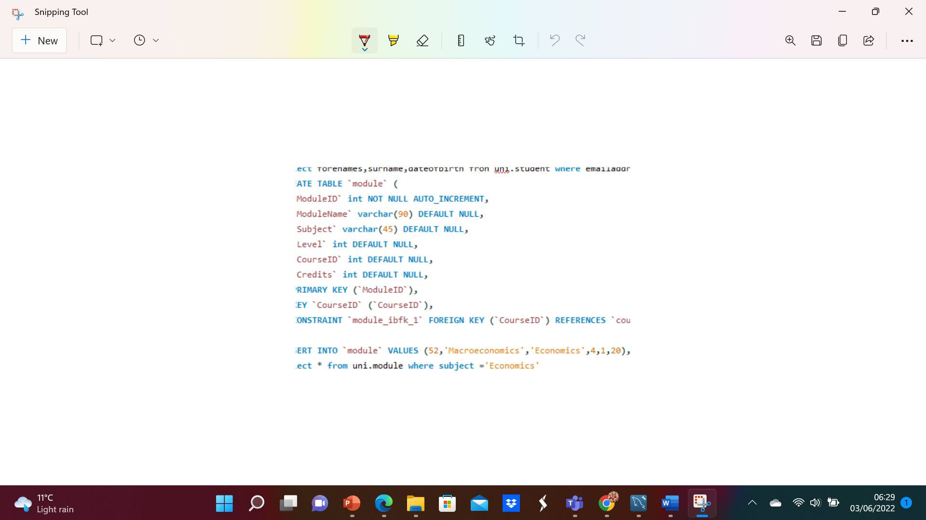

3 Insert a record for a new course named Deep-Space Radar Telemetry
write an insert to insert records for the following modules:
String Theory
Exotic Matter
Harnessing the Einstein-Rosen Bridge
Supercollision and miniature Black Holes
(these modules are worth 20 credits each, at level 6 and are taught on the Quantum Physics Course)
- INSERT INTO uni.course(CourseName)VALUES('Deep-Space Radar Telemetry');

INSERT (ModuleName,subject,level,CourseID,credits)
VALUES('String Theory','Physics',6,6,20)
('Exotic Matter','Physics',6,6,20)
('Harnessing the Einstein-Rosen Bridge''Physics',6,6,20)
('Supercollision and miniature Black Holes''Physics',6,6,20);

